Lab 18
Normalization
- In what normal form is the following LOTS relation schema with the respect to the restrictive interpretations of normal form that take only the primary key into account? Would it be in the same normal form if the general definitions of normal form were used?
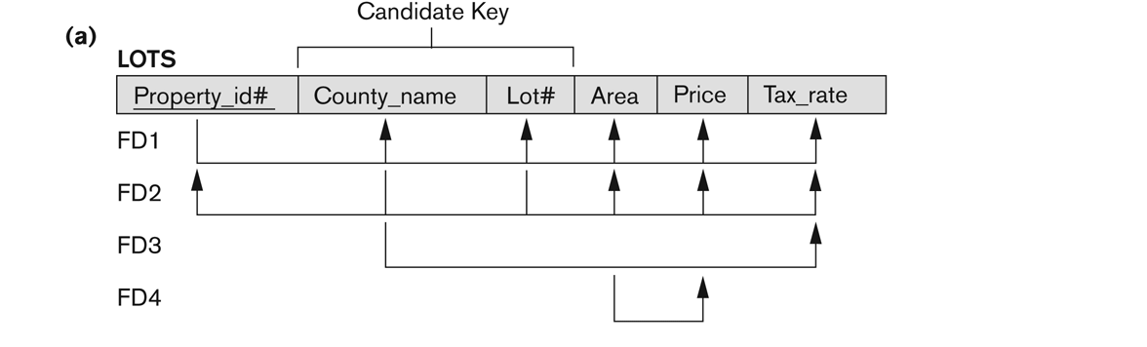

- Prove that any relation schema with two attributes is in BCNF.

- Consider the universal relation
R = {A, B, C, D, E, F, G, H, I,J}
F = { AB → C, A → DE, B → F, F → GH, D → IJ }.
What is the key for R?
Decompose R into 2NF, then 3NF relations.

- Consider the universal relation
R = {A, B, C, D, E, F, G, H, I}
G = { AB → C, BD → EF, AD → GH, A → I, H → J }
What is the key for R? Decompose R into 2NF, then 3NF relations.

- Given relation R(A,B,C,D,E) with FDs = {AB → C; CD → E; DE → B}
AB a candidate key of this relation? If not, is ABD?

- Consider the following relations for an order-processing application database at ABC, Inc.
ORDER (O#, Odate, Cust#, Total_amount)
ORDER-ITEM (O#, I#, Qty_ordered, Total_price, Discount%)
Assume that each item has a different discount. The Total_price refers to one item, Odate is the date on which the order was placed, and the Total_amount is the amount of the order. If we apply a natural join on the relations Order-Item and Order in this database, what does the resulting relation schema look like? What will be its key? Show the FDs in this resulting relation. Is it in 2NF? Is it in 3NF? Why or why not? (State any assumptions you make.)

- Consider the following relation:
CAR_SALE(Car#, Date_sold, Salesman#, Commision%, Discount_amt
Assume that a car may be sold by multiple salesmen and hence {CAR#, SALESMAN#} is the primary key. Additional dependencies are:
Date_sold → Discount_amt and Salesman# → commission%
Based on the given primary key, is this relation in 1NF, 2NF, or 3NF? Why or why not? How would you successively normalize it completely?

- Consider the following relation for published books:
BOOK (Book_title, Authorname, Book_type, Listprice, Author_affil, Publisher)
Author_affil referes to the affiliation of the author. Suppose the following dependencies exist:
Book_title → Publisher, Book_type
Book_type → Listprice
Author_name → Author_affil

